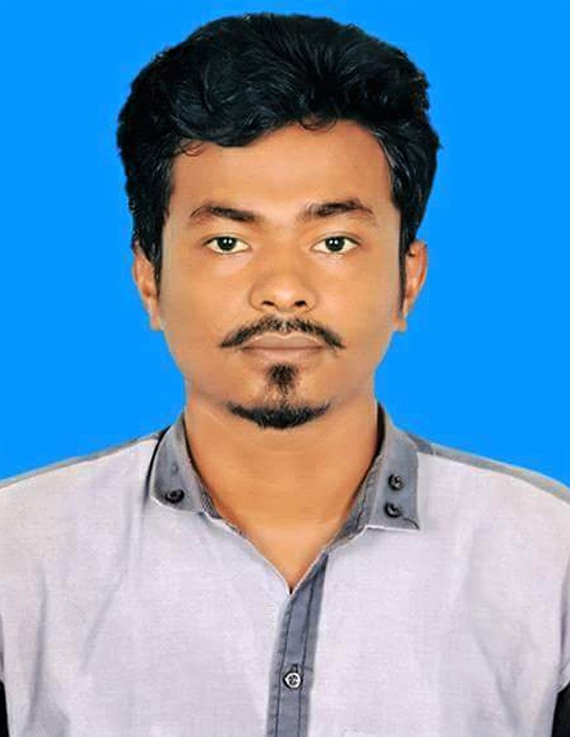

PERSONAL INFORMATION | Md. Saykat Rana
 | House of Firoz Ahmed R/A, Pata Bari, Ukhya, Cox’s Bazar.
 | +880 1672523821
 | shaykatrana88@gmail.com
 | Date of birth : 20/02/ 1993 || Sex : Male|| Nationality : Bangladeshi
 | Marital status: Single || Religion: Islam|| Blood Group: A+
PARENTS
Father’s Name : Md. Kholilur Rahman||
Mother’s Name : Shahnaz Begum ||
CAREER SUMMARY
 | A Highly organized and detail oriented professional with 3.5 years of successful Private company & Humanitarian Organization experience providing through skillful support to management, backed by strong relevant educational background. I am seeking for an opportunity for individual contribution and growth.
WORK EXPERIENCE
August 2018 to till now. | Medical Data Entry Operator at MSF-Holland, Ukhiya  Major Duties:  - Enter medical data (e.g. patient data, dates of visit, content of prescription, viral load, etc) in mission database on a regular basis and according to MSF protocols.  - Participate in compilation of data both from MSF structure and from collaborating health facilities.  - Participate in the search for missing data.  - Update files of existing patients and make any corrections needed.  - Make regular back-ups of all data processed.  - Look after all equipment provided and keep recording area clean and tidy, giving special importance to all patients files.  - Report any issue concerning data management to superior.  - Assist supervisors to prepare data in time.  - Support data colleagues to prepare data.  - Elaborate statistical report when required by the medical team.  - Maintain all the information from different departments and enter them into confidential medical data system to make sure that all the valuable in formations are ready before deadline.  - Store the hard copies of the patients information files In a secure place.  - Ensure, promote and maintain confidentiality regarding all information registered.
1 January 2019 to 1 April 2019 | Radio Operator at Medecins Sans Frontiers(OCP), Ukhiya.  Major Duties:  - Operating the HF and VHF radios, avoiding using any sensitive or  security related information and following the MSF security rules. Ensures radio frequencies’ (HF and WHF) quality and transmission capacity. Installs and programs frequencies in all type of radios when necessary.  - Ensuring that messages are well copied/passed to all people concerned and records the messages on the radio log book. Responding to radio contacts from other approved organizations and forwarding it on the information via this channel.  - Making radio contacts with reference bases (capital and/or field) according to communication rules / schedules and forwards all information concerning the security of the teams to the project/capital coordinator.  - Monitoring and registering any movement, of people, vehicles. In inform line manager of any delays.  - Supervising and monitoring the VHF radio allocation book (handset) and registering the loan of handset to all staff, following it up on a regular basis.  - Installing, operating and performing preventive maintenance check on assigned equipment, checking that the equipment is working properly and immediately informing the line manager of any damage/loss/theft.
14 April 2018 to 30 November 2018 | Medical Translator at Medecins Sans Frontiers(OCP), Ukhiya.  Major Duties:  - Assists MSF international medical team especially MSF doctor by providing good oral and written translations in medical activities.  - Provides oral interpretation from English to Bangla and Rohingya.  - Translate document from English to Bangla and Rohingya.  - Respect confidentiality in all matters.  - Assist in and carries out other project activities and tasks, as assigned.
EDUCATION
2013-2018 | Bachelors Degree – BBA (Bachelor of Business Administration)  National University, Chittagong, Bangladesh.
2011-2012 | Higher Secondary Certificate (HSC) – in Business Studies  Kulgaon City Corporation College, Chittagong, Bangladesh
2009-2010 | Secondary School Certificate (SSC) – in Business Studies  Rahmania High School, Chittagong, Bangladesh
PERSONAL SKILLS
Mother Tongue(S) | Bangla
Other language(s) | UNDERSTANDING |  |  | SPEAKING | WRITING
Other language(s) | Listening | Reading |  | Spoken interaction
English | Excellent | Excellent |  | Excellent | Excellent
Rohingiya/Chittagonian Local Dialect | Excellent | - |  | Excellent | -
Communication skills | Good communication skills gained through my experience.
Computer skills | Application: |  | MS Excel, MS Word, MS Power Point etc. all office necessary
Computer skills | Internet: |  | Regular User
Other skills | Analyzing, Team Work, Stress Management.

HOBBIES
 | Traveling to new places. Knowing about new cultures and introducing with new people.
REFERENCES
Name  Designation  Organization  Email  Cell phone | Md Inul Rayhan  Data Supervisor  MSF-OCA (KTP Project)  inulrayhan@gmail.com  +8801832827912 |  | Razwan Siddik  Supply Chain Manager  UNHCR  razwan.scm@gmail.com  +8801675628568

